**1.Launch a Secure Windows EC2 Instance:**

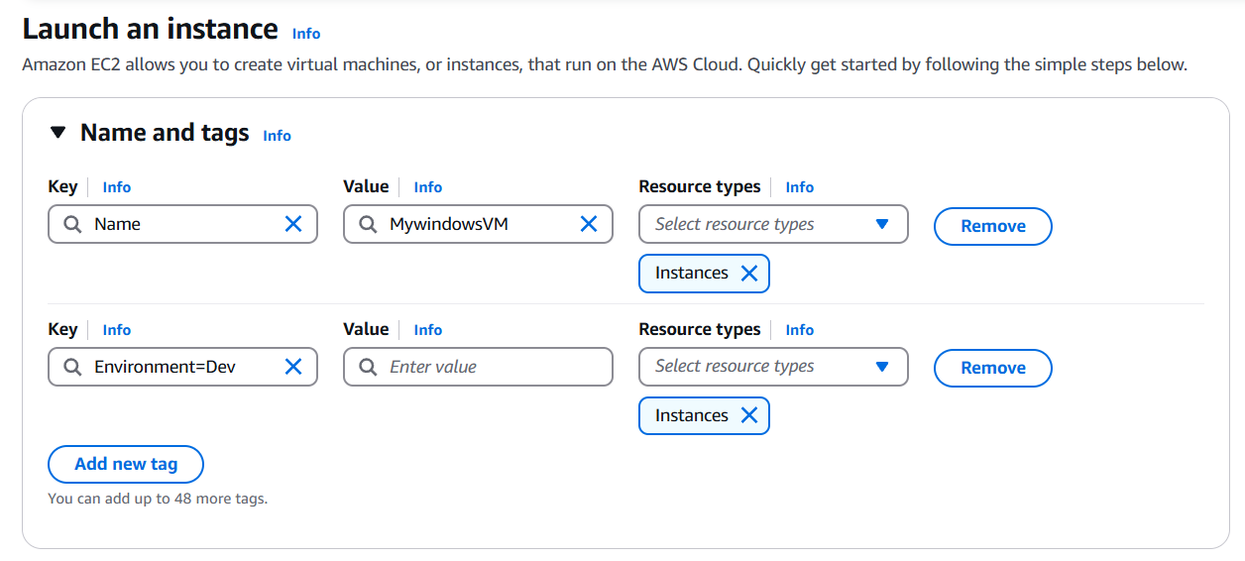

**2.AMI: Microsoft Windows Server 2019/2022 Base**

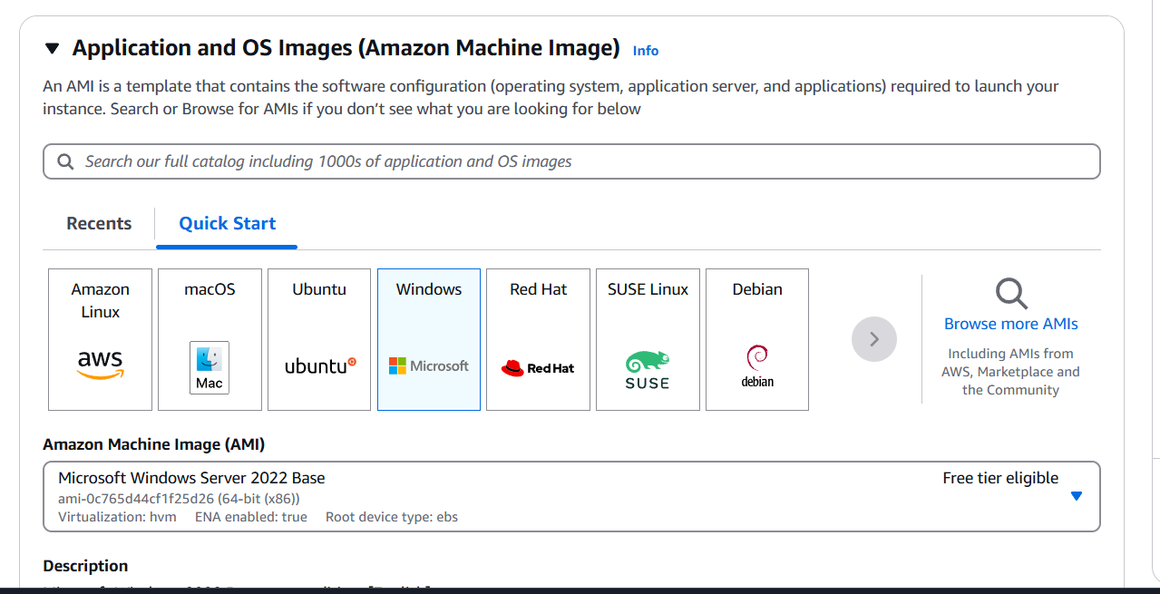

**3.Security Group**: 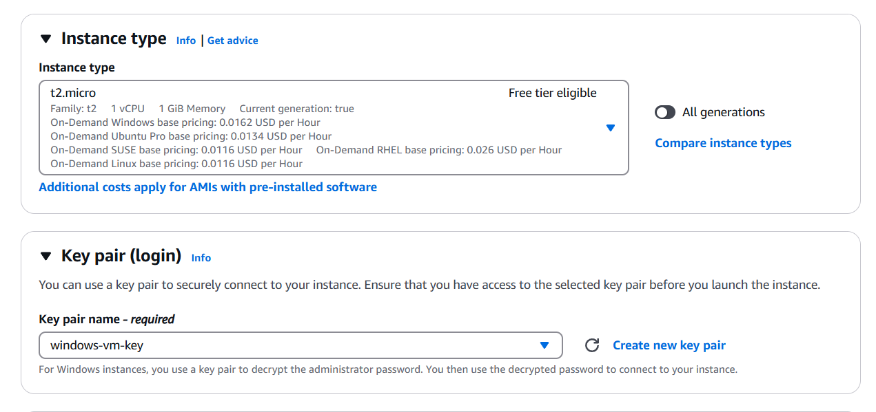

4. **Networking**:

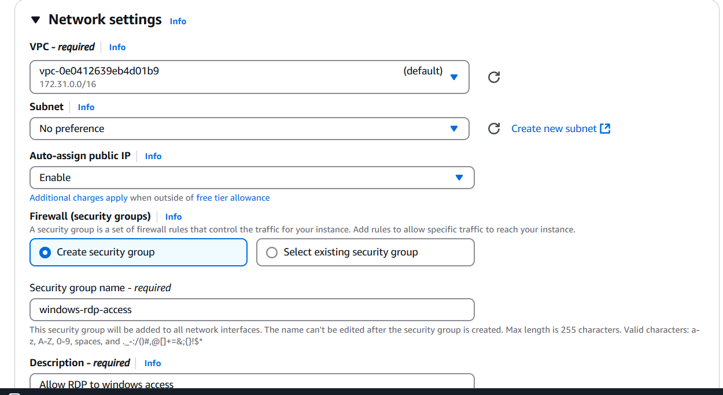

**5.Security Group**:

* Inbound Rules

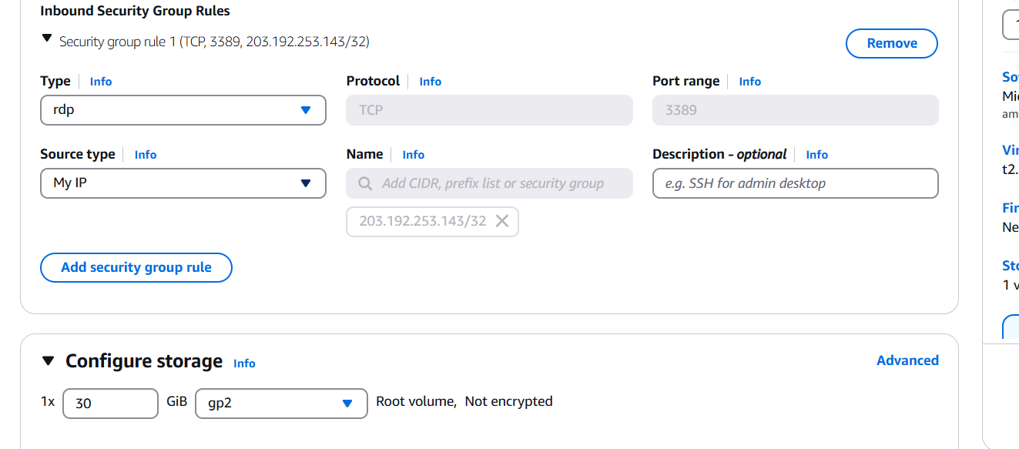

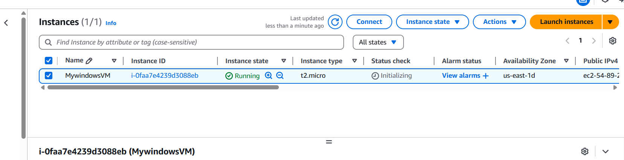

**6.Connect EC2 using RDP client**: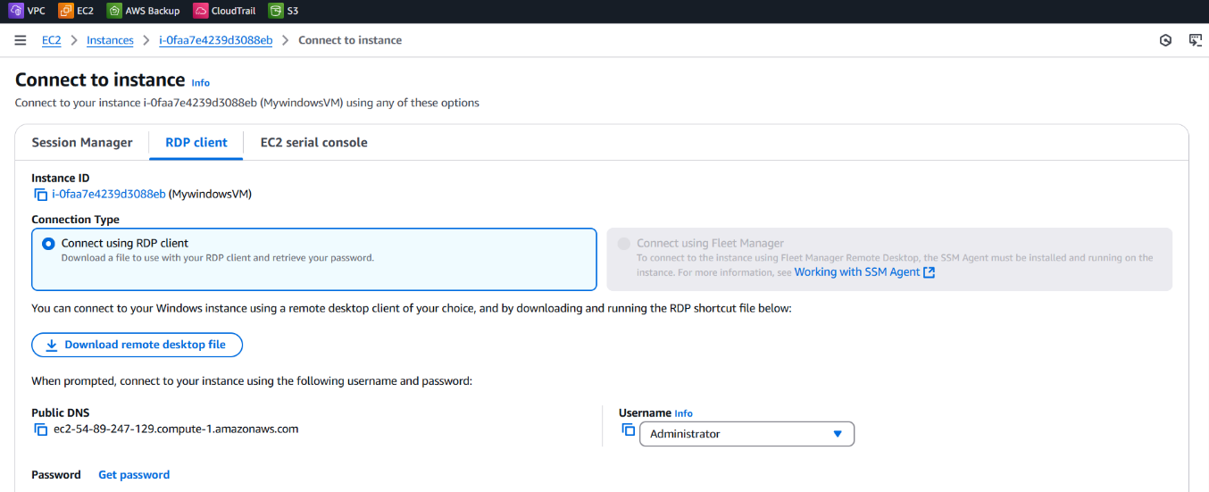

**7.get Windows Password by uploading .pem file:**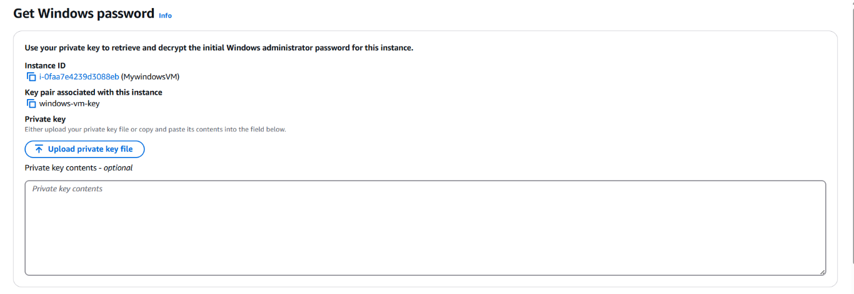

**8.connect to VM using Remote desktop connection:**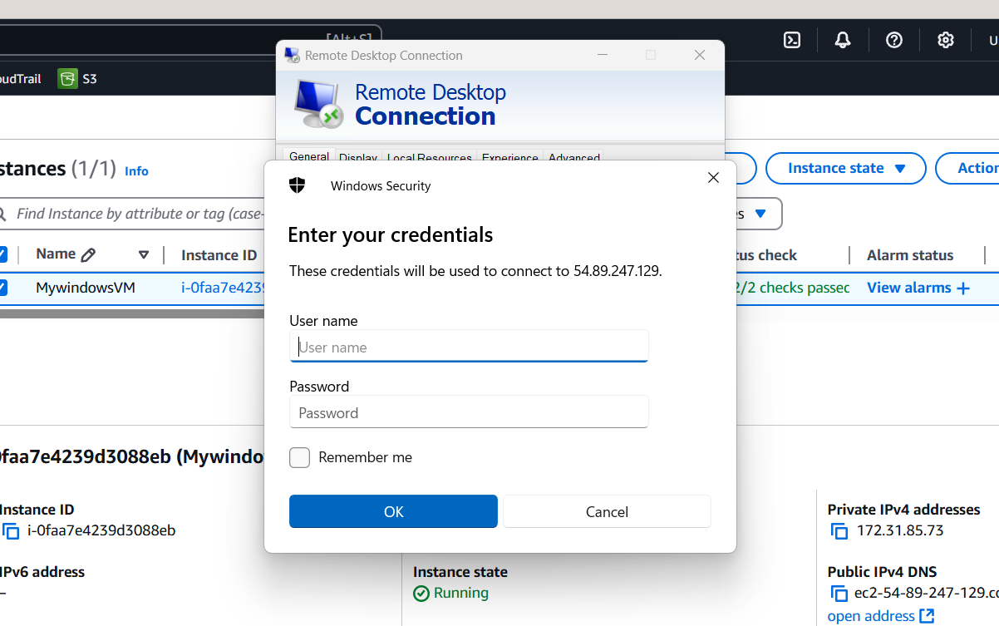

**9.successfully connected to VM** :

